**Department of Software Engineering**

# Lab Manual

**SEN361-L Data Communication and Computer Networks**

Instructor’s Name: Asna Ansari

Student’s Name: MuhammadSoman

Roll No.: 67519

Department: BESE

**Department of Software**

**Engineering**

# Lab Manual

**SEN361-L Data Communication and Computer Networks**

Prepared By:

## AMMAR ALI QAZI

Reviewed / Approved By:

_____________________

**Faculty of Engineering Sciences & Technology Iqra University**

**DCCN (LAB)**

|  |  |
| --- | --- |
| **Instructor** | AMMAR ALI QAZI |
| **Designation** | Lecturer |
| **Department** | FEST |
| **Semester** | Fall 2024 |
| **Office Location** | 7th Floor 708 |
| **Email** | ammar.ali01@iqra.edu.pk |
| **Office Hours** | 8:30 - 4:30 Mon-Fri |
| **Prerequisite(s)** | Data Communication and Computer Network |
| **Credit Hours** | 1 |

|  |
| --- |
| **Lab Objective(s)** |
| The course aims to equip students with the practical skills needed to establish console sessions and configure network devices using Hyper Terminal. Students will learn to construct and utilize different types of network cables and command line fundamentals to manage and troubleshoot network issues effectively. |

|  |
| --- |
| **Lab Contents** |
| The lab sessions include constructing crossover and straight-through cables, fundamental command line operations, and troubleshooting techniques using Ping and Telnet. Students will practice IP addressing, configure various routing protocols such as RIP and OSPF, and manage IOS images with TFTP. Additionally, the course covers VLAN configuration and the use of routing tables to understand and implement effective network routing strategies. |

|  |  |  |  |
| --- | --- | --- | --- |
|  | **Course Textbook / Reference Books and Supplementary Reading Material** | | |
| S No | Title | Author(s) | Edition |
| 1 | Computer Networking: A Top-Down Approach | James Kurose and Keith Ross |  |

|  |  |
| --- | --- |
|  | **Course Learning Outcomes (CLOs)** |
| **CLO 1** | ***Apply*** the concepts of various data structures and their algorithms, and utilize them in implementing simple applications. |
| **CLO 2** | ***Practice*** problem-solving and the use of data warehousing and data mining techniques through both individual and collaborative lab-based activities. |
| **CLO 3** | ***Analyze and implement*** efficient algorithms for complex data processing tasks, leveraging advanced programming techniques and tools. |

|  |  |  |  |  |
| --- | --- | --- | --- | --- |
| **CLO/GA Mapping and Assessment** | | | | |
| **CLOs** | **Related GAs** | **Level of Learning** | **SDGs** | **CLO Attainment checked in** |
| CLO1 | GA-2 (Knowledge for Solving Computing Problems) | C3 (Application) | SDG 4 | Labs, Mid, Final, OEL/CCA |
| CLO2 | GA-6 (Individual & Team Work) | A2 (Respond) | SDG 9 | Labs, Mid, Final, OEL/CCA |
| CLO3 | GA 4 Design/Development of Solutions | A4 | SDG 9 | Labs, Mid, Final, OEL/CCA |
| Note: On successful completion of course **GA 1 (Academic Education)** will automatically attain. | | | | |

|  |  |
| --- | --- |
| **Grading Br** | **eak Up / Policy** |
| Lab Manual + Lab Performance | 20% |
| Mid Exam | 25% |
| Final Exam | 40% |
| Lab Project / CEA | 15% |

|  |  |  |  |
| --- | --- | --- | --- |
| **Assessment tools** | **CLO1** | **CLO2** | **CLO 3** |
| Lab Manual | 20% | 25 % | 20% |
| Mid Exam | 25 % | 25 % | 25% |
| Final Exam | 43.75 % | 25% | 40% |
| Lab Project / CEA | 12.5 % | 25% | 25% |
| Total | 100 % | 100% | 100% |

CONTENTS

|  |  |  |  |  |  |
| --- | --- | --- | --- | --- | --- |
| Lab. No. | Date | List of Experiment | Total Marks | Signature | Page # |
| 1. |  | 1. Introduction to Network   Fundamentals   1. Cisco Packet Tracer Installation |  |  |  |
| 2. |  | 1. Connect the computers in Local Area Network. 2. Study of basic network command and Network configuration commands. 3. IP Addressing Basics |  |  |  |
| 3. |  | Static Routing on cisco packet tracer |  |  |  |
| 4. |  | FLSM (Fixed Length Subnet Mask) |  |  |  |
| 5. |  | VLSM (Variable Length Subnet Mask) |  |  |  |
| 6. |  | Open-ended Lab |  |  |  |
| 7. |  | Mid Term Examination |  |  |  |
| 8. |  | 1. Dynamic Routing on cisco packet tracer 2. Configure RIP (Routing   Information Protocol) V1 |  |  |  |
| 9. |  | Configure Routing Information  Protocol version 2 |  |  |  |
| 10. |  | Configure OSPF (Open Shortest Path First) Single Area Basic Switch Configuration |  |  |  |
| 11. |  | To construct multiple router networks and understand the operation of EIGRP Protocol |  |  |  |
| 12. |  | Basic Switch Configuration |  |  |  |
| 13. |  | Virtual LANs |  |  |  |
| 14. |  | Assessment of Open-ended lab |  |  |  |
| 15. |  | Final Examination |  |  |  |

### Psychomotor Rubrics for Hardware based Lab

**Course Name (Course Code): ___________________________________________________________**

#### Semester: ___________________________________________________________

|  |  |  |  |  |
| --- | --- | --- | --- | --- |
| **Criteria** | **Exceeds Expectations**  **(>=90%)** | **Meets Expectations (70%-89%)** | **Developing (50%69%)** | **Unsatisfactory (<50%)** |
| **Experimental Setup** | Able to setup experiment  independently with complete  understanding of each step | Able to setup experiment  independently with adequate  understanding of each step | Can setup major part of the  experiment with assistance | Can’t set up the experiment even with assistance |
| **Procedure** | Able to follow the procedure completely with simplification or develop alternate procedure | Able to follow the procedure completely | Able to follow major part of the procedure with errors or omissions | Unable to follow the procedure |
| **Experimental Results** | Able to achieve all the desired results  with alternate ways to improve measurements | Able to achieve all the desired results | Able to achieve most of the desired results with errors | Unable to achieve the desired results |
| **Laboratory Manual** | All sections of the report are very well written and  technically accurate. | All sections of the report are  technically accurate. | Few sections of the report contain technical errors. | All sections of the report contain  multiple technical errors. |

### Psychomotor Rubrics Assessment Hardware Lab

**Course Name (Course Code): ________________________________________________________**

#### Semester: _________________________________________________________

|  |  |  |  |  |  |  |  |
| --- | --- | --- | --- | --- | --- | --- | --- |
| Lab # |  | Score Allocation | | | | | |
| **Experimental Setup Marks (3)** |  | **Procedure**  **Marks (2)** | **Experimental Results Marks (3)** | | **Laboratory Manual Marks (2)** | **Total Marks**  **(10)** |
| 1 |  |  |  |  | |  |  |
| 2 |  |  |  |  | |  |  |
| 3 |  |  |  |  | |  |  |
| 4 |  |  |  |  | |  |  |
| 5 |  |  |  |  | |  |  |
| 6 |  |  |  |  | |  |  |
| 7 |  |  |  |  | |  |  |
| 8 |  |  |  |  | |  |  |
| 9 |  |  |  |  | |  |  |
| 10 |  |  |  |  | |  |  |
| 11 |  |  |  |  | |  |  |
| 12 |  |  |  |  | |  |  |
| 13 |  |  |  |  | |  |  |
| 14 |  |  |  |  | |  |  |
| Total Mark | | 140 | | | Total Obtained Marks | |  |

***Overall Score: ___________out of 14 Examined by****: ___________________________*

***(Obtained Score / 140) x 14 (Name and Signature of lab instructor)***

### Psychomotor Rubrics for Software based Lab

***Course Name (Course Code): ___________________________________________________________***

#### *Semester: ___________________________________________________________*

|  |  |  |  |  |
| --- | --- | --- | --- | --- |
| **Criteria** | **Exceeds Expectations (>=90%)** | **Meets Expectations (70%-89%)** | **Developing (50%-69%)** | **Unsatisfactory (<50%)** |
| **Software Skills** | Ability to use software with its standard and advanced features without assistance | Ability to use software with its standard and  advanced features with minimal assistance | Ability to use software with its  standard features with assistance | Unable to use the software |
| **Programming**  **/ Simulation** | Ability to program/ simulate the lab tasks with simplification | Ability to program/ simulate the lab tasks without errors | Ability to program/ simulate lab tasks with errors | Unable to program/simulat  e |
| **Results** | Ability to achieve all the desired results with alternate ways | Ability to achieve all the desired results | Ability to achieve most of the  desired results with errors | Unable to achieve the desired results |
| **Laboratory Manual** | All sections of the report are very well written and technically accurate. | All sections of the report are technically accurate. | Few sections of the report contain technical errors. | All sections of the report  contain multiple technical errors. |

### ****Private Network Classes (used in LANs):****

* **Class A:** 10.0.0.0 to 10.255.255.255
* **Class B:** 172.16.0.0 to 172.31.255.255
* **Class C:** 192.168.0.0 to 192.168.255.255

These ranges are **not routable** on the internet and are used inside private networks.

### Psychomotor Rubrics Assessment Software based Lab

**Course Name (Course Code): ________________________________________________________**

#### Semester: _________________________________________________________

|  |  |  |  |  |  |  |
| --- | --- | --- | --- | --- | --- | --- |
| Lab # | Score Allocation | | | | | |
| **Software Skills Marks (3)** | **Programming/**  **Simulation**  **Marks (2)** | **Experimental Results Marks (3)** | | **Laboratory Manual Marks (2)** | **Total Marks (3)** |
| 1 |  |  |  | |  |  |
| 2 |  |  |  | |  |  |
| 3 |  |  |  | |  |  |
| 4 |  |  |  | |  |  |
| 5 |  |  |  | |  |  |
| 6 |  |  |  | |  |  |
| 7 |  |  |  | |  |  |
| 8 |  |  |  | |  |  |
| 9 |  |  |  | |  |  |
| 10 |  |  |  | |  |  |
| 11 |  |  |  | |  |  |
| 12 |  |  |  | |  |  |
| 13 |  |  |  | |  |  |
| 14 |  |  |  | |  |  |
| Total Marks | | 140 | | Total Obtained marks | |  |

***Overall Score: ___________out of 14 Examined by****: ___________________________* ***(Obtained Score / 140) x 14 (Name and Signature of lab instructor)***

### Affective Domain Rubrics Assessment

**Course Name (Course Code): ________________________________________________________**

#### Semester: _________________________________________________________

|  |  |  |  |  |
| --- | --- | --- | --- | --- |
| **CATEGORY** | **Excellent (100% - 85%)** | **Good (84% - 75%)** | **Fair (74% - 60%)** | **Poor (Less than 60%)** |
| **Speaks Clearly** | Speaks clearly and distinctly all the time, and confidently. | Speaks clearly and distinctly most of the  time, but is confused for a brief period of time, however, recovers. | Speaks clearly and distinctly most of the  time, but seems not confident about what has been delivered. Shows lack of confidence. | Often mumbles or cannot be understood and clearly lacks  confidence in delivering  the content |
| **Points:** |  |  |  |  |
| **Preparedness** | Student is completely prepared and has obviously rehearsed. | Student seems pretty prepared but might have needed a couple more rehearsals. | The student is somewhat prepared, but it is clear that rehearsal was lacking. | Student does not seem at all prepared to present. |
| **Points** |  |  |  |  |
| **Answer back** | Student calmly listens to the questions and responds  to the question confidently  and correctly | Student calmly listens to the questions, responds  confidently but some of the responses are incorrect. | Student shows anxiety while listening to the  questions, and gives some correct responses, but  some of the responses are incorrect. | Student shows anxiety while listening to the  questions, and most of the responses are incorrect. |
| **Points:** |  |  |  |  |
| **Posture, Eye**  **Contact &**  **Speaking Volume** | Stands up straight, looks relaxed and confident.  Establishes eye contact with everyone in the room during the presentation.  Volume is loud enough to be heard by all members in  the audience throughout the presentation. | Stands up straight and establishes eye contact  with everyone in the room during the presentation.  Volume is loud enough to be heard by the audience, but is sometimes not audible. | Sometimes stands up straight and establishes  eye contact. Volume is loud enough to be heard  by the audience, but many sentences spoken are not clear. | Lazy and informal posture. Does not look at people during the  presentation. Volume is also too soft to be heard by the audience. |
| **Points:** |  |  |  |  |

***Overall Score: ___________out of 14 Examined by****: ___________________________*

***(Name and Signature of lab instructor)***

#### *Open Ended Lab Assessment Rubrics*

***Course Name (Course Code): ________________________________________________________***

##### *Semester: ________________________________________________________*

|  |  |  |  |
| --- | --- | --- | --- |
| **Criteria and Scales** | | | |
| **Excellent** **(10-8)** | **Good**  **(7-5)** | **Average (4-2)** | **Poor (1-0)** |
| **Criterion 1:** **Understanding the Problem:** How well the problem statement is understood by the student | | | |
| Understands the problem Adequately understands the Inadequately defines the Fails to define the problem clearly and clearly problem and identifies the problem and identifies the adequately and does not identifies the underlying underlying issues. underlying issues. identify the underlying issues.issues. | | | |
| **Criterion 2: Research:** The amount of research that is used in solving the problem | | | |
| Contains all the information needed for solving the problem | Good research, leading to a successful solution | Mediocre research which may or may not lead to an adequate solution | No apparent research |
| **Criterion 3: Class Diagram:** The completeness of the class diagram | | | |
| Class diagram with Class diagram with Class diagram with No Class diagram complete notationsincomplete notations improper naming  convention and notations | | | |
| **Criterion 4: Code:** How complete and accurate the code is along with the assumptions | | | |
| Complete Code according to the class diagram of the given case with clear assumptions | Incomplete Code according to the class diagram of the given case with clear  assumptions | Incomplete Code according to the class diagram of the given case with unclear assumptions | Wrong code and naming  conventions |
| **Criterion 5: Report:** How thorough and well organized is the solution | | | |
| All the necessary information clearly organized for easy use in solving the problem | Good information organized well that could lead to a good solution | Mediocre information which may or may not lead  to a solution | No report provided |

#### *Open Ended Lab Assessment Rubrics*

***Course Name (Course Code): ________________________________________________________***

##### *Semester: ________________________________________________________*

|  |  |  |  |  |
| --- | --- | --- | --- | --- |
| **Criteria and Scales** | | | | |
| **Excellent (10-8)** | **Good**  **(7-5)** | **Average**  **(4-2)** | **Poor (1-0)** | **Total Marks 10** |
| **Criterion 1:**  **Understanding the Problem:** How well the problem statement is understood by the student | | | | |
| (10-8) | (7-5)% | (4-2)% | (1-0)% |  |
| **Criterion 2:**  **Research**: The amount of research that is used in solving the problem | | | | |
| (10-8) | (7-5)% | (4-2)% | (1-0)% |  |
| **Criterion 3:**  **Class Diagram:** The completeness of the class diagram | | | | |
| (10-8) | (7-5)% | (4-2)% | (1-0)% |  |
| **Criterion 4:**  **Code:** How complete and accurate the code is along with the assumptions | | | | |
| (10-8) | (7-5)% | (4-2)% | (1-0)% |  |
| **Criterion 5:**  **Report**: How thorough and well organized is the solution | | | | |
| (10-8) | (7-5)% | (4-2)% | (1-0)% |  |
| Total | | | | **(____/5)** |

Total marks obtained: ____________________

Name and Signature of lab instructor: _____________________

### Rubrics for Lab Project / CCA

***Course Name (Course Code): ___________________________________________________________ Semester****: __________________________________________________________*

|  |  |  |  |  |
| --- | --- | --- | --- | --- |
| **Criteria** | **Exceeds**  **Expectations**  **(>=90%)** | **Meets**  **Expectations**  **(70%-89%)** | **Developing (50%-69%)** | **Unsatisfactory (<50%)** |
| **Project**  **Presentation +**  **Project**  **Demonstration** | Ability to demonstrate the project with achievement of required objectives having clear understanding of project limitations and future enhancements.  Hardware and/or  Software modules are fully functional, if applicable. | Ability to demonstrate the project with achievement of required objectives but understanding of project limitations and future enhancements is insufficient.  Hardware and/or Software modules are functional, if applicable. | Ability to demonstrate the project with achievement of a*t least 50% required objectives and insufficient understanding of project limitations and future enhancements.  Hardware and/or  Software modules are partially functional, if applicable. | Ability to demonstrate the project with achievement of less than 50% required objectives and lacks in understanding of project limitations and future enhancements.  Hardware and/or Software modules are not functional, if applicable. |
| **Project Report** | All sections of the Project report are very well- written and technically accurate. | All sections of the Project report are technically accurate. | Few sections of the Project report contain technical errors. | Project report has  several grammatical/ spelling errors and sentence construction is poor. |
| **Viva** | Able to answer the questions easily and correctly across the project. | Able to answer the questions related to the project | Able to answer the questions but with  mistakes | Unable to answer the questions |

Total marks: ____________________

Name and Signature of lab instructor: _____________________

### Project / CCA Rubric based Assessment

**Course Name (Course Code): ___________________________________________________**

**Semester: ____________________________________________________________________**

|  |  |  |  |  |
| --- | --- | --- | --- | --- |
| Project # | Score Allocation | |  |  |
| **Project Presentation + Project**  **Demonstration Marks (5)** | **Project Report**    **Marks (3)** | **Viva**    **Marks (3)** | **Total**  **Marks**  **(10)** |
| 1 |  |  |  |  |
| 2 |  |  |  |  |
|  | Total Obtained Score | |  |  |

Total marks obtained: ____________________

Name and Signature of lab instructor: _____________________

### Mid Term Rubrics

**Course Name (Course Code): _________________________________________________________**

#### Semester: __________________________________________________________

|  |  |  |  |  |
| --- | --- | --- | --- | --- |
| **Criteria** | **Exceeds Expectations (>=90%)** | **Meets Expectations (70%-89%)** | **Developing (50%-69%)** | **Unsatisfactory (<50%)** |
| **Performance** | Able to present full knowledge of both problem and solution. | Able to present adequate knowledge of both problem and solution | Able to present sufficient knowledge of both problem and solution | No or very less knowledge of both problems and solution |
| **Viva** | Able to answer the questions easily and correctly | Able to answer the questions | Able to answer the questions but with mistakes | Unable to answer the questions |

#### *Mid Term Rubrics based Assessment*

***Course Name (Course Code): _________________________________________________________***

##### *Semester, Batch: _____________________________________________________*

|  |  |  |
| --- | --- | --- |
|  | **Score All** | **ocation** |
| **Performance** |  | ______ /20 |
| **Viva** |  | _____ /5 |
| **Total Obtained Score** |  | **______/ 25** |

***Examined by****:*

***(Name and Signature of concerned lab instructor)***

#### *Final Term Rubrics*

***Course Name (Course Code): ________________________________________________________ Semester: _________________________________________________________***

|  |  |  |  |  |
| --- | --- | --- | --- | --- |
| **Criteria** | **Exceeds Expectations (>=90%)** | **Meets Expectations (70%-89%)** | **Developing (50%-69%)** | **Unsatisfactory (<50%)** |
| **Performance** | Able to present full knowledge of both problem and solution. | Able to present adequate knowledge of both problem and solution | Able to present sufficient knowledge of both problem and solution | No or very less knowledge of both problems and solution |
| **Viva** | Able to answer the questions easily and correctly | Able to answer the questions | Able to answer the questions but with mistakes | Unable to answer the questions |

#### *Final Term Rubrics based Assessment*

***Course Name (Course Code): ____________________________________________________***

##### *Semester, Batch: _________________________________________________*

|  |  |  |
| --- | --- | --- |
|  | Score All | ocation |
| **Performance** |  | _____ /45 |
| **Viva** |  | _____ /5 |
| **Total Obtained Score** |  | **_____/ 50** |

***Examined by****:*

***(Name and Signature of concerned lab instructor)***

**Final Lab Assessment**

|  |  |  |  |
| --- | --- | --- | --- |
| **Assessment Tool** | **CLO-1 (20)** | **CLO-2 (20)** | **CLO-3 (10)** |
| **Lab Manual** |  |  |  |
| **Subject Project / Viva** |  |  |  |
| **Lab Exam / Viva** |  |  |  |
| **Score Obtained** |  |  |  |
|  | **Total Score: ________ out of 50** | |  |

***Examined by****:*

***(Name and Signature of concerned lab instructor)***

##### Lab Session 1

**Objective:**

To study basic understanding of Network Fundamentals and tool installation.

* Network Elements
* Network Types
* Introduction to Cisco Packet Tracer (Tool) **Introduction:**

**Computer Network:**

A computer network is a collection of computers and devices connected together via communication devices and transmission media. For example, it may connect computers, printers and scanners etc.

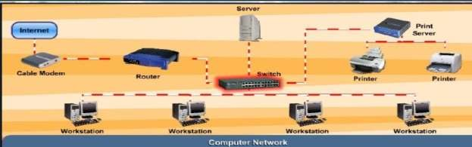

**Network Elements:**

Network elements mean the elements a network mostly comprises of. Basic elements of a computer network include hardware, software, and protocols. The interrelationship of these basic elements constitutes the infrastructure of the network. The list of the equipment could be much longer but the basic network elements are as follows:

* Routers
* Switches
* Hubs
* Cables (Copper, Optical Fiber etc)

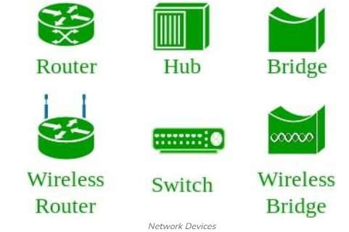

**Routers:**

In packet-switched networks such as the Internet, a router is a device that determines the next network point to which a packet should be forwarded toward its destination. Router has two main functions: Routing and Forwarding.

**Switch:**

In a telecommunications network, a switch is a device that channels incoming data from any of multiple input ports to the specific output port that will take the data toward its intended destination.

**Hub:**

A hub is a common connection point for devices in a network. Hubs are commonly used to connect segments of a LAN. A hub contains multiple ports. When a packet arrives at one port, it is copied to the other ports so that all segments of the LAN can see all packets.

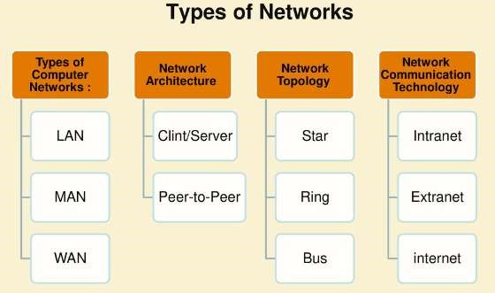

**Network Types:**

* LAN (Local Area Network)
* MAN (Metropolitan Area Network)
* WAN (Wide Area Network)

**LAN (Local Area Network):**

A local area network is a network that connects Local Area Network (LAN) computers and device in a limited geographical area such as a home, school computer laboratory, office building.

**MAN (Metropolitan Area Network):**

A metropolitan area network (MAN) is a high speed Metropolitan Area network that connects local area networks in a Network (MAN) metropolitan area such as city or town and handles bulk of communication activity across the region A MAN typically includes one or more LAN but covers a smaller geographic area than a WAN

**WAN (Wide Area Network):**

A wide area network is a network that covers a large Wide Area Network geographical area such country or the world (WAN) WAN combines many types of media such as telephone lines, cables and radio wave. A WAN can be one large network or can consist of two or more LANs connected together. The internet is the world’s largest WAN.

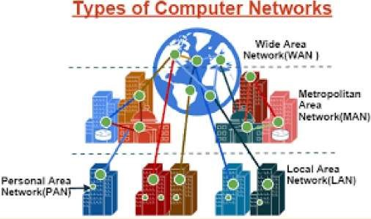

**Network Models/Architectures:**

Network architecture is the overall design of a Network Architecture computer network that describes how a computer network is configured and it is mainly focuses on the function what strategies are being used. It is also known as network model or network design of the networks. Two main network architecture:

* Server/client model
* Peer-to-peer model

**Server/client model:**

On a client/server network, one computer act as a server that provides services and the other computers (client) on the network request services from the server. A server is a computer that controls access to the hardware, software and other resources on the network and provides a centralized storage area for program. A client is a computer that request services from a server computer.

**Peer-to-peer model:**

Peer-to-peer is a simple, inexpensive network that Peer-to-Peer typically connects fewer than 10 computers. All computers in the network have equal capabilities to use the resources (hardware, software, data and file) available on the network. With peer-to-peer networks, there is no central server.

**Introduction and Installation of Cisco Packet Tracer:**

Brief completely in Lab about Cisco Packet Tracer working environment.

https://www.filehorse.com/download-cisco-packet-tracer-32/27899/download/#google_vignette

**STEPS:**

1. Click on the link to download Cisco Packet Tracer version 6.4 (Student Version).
2. Once the download is complete, open the installer to begin the installation process.
3. During installation, make sure to check the box that says "I accept the agreement."
4. Continue with the installation process by following the on-screen instructions.
5. Once the installation is complete, you can start using Cisco Packet Tracer.

##### Task #1

Write advantage and disadvantage of Router and Switches.

**Router:**

* **Advantage:** Connects different networks (e.g., LAN to the internet).
* **Disadvantage:** Slower than switches due to complex processing.

**Switch:**

* **Advantage:** Faster data transfer within a local network.
* **Disadvantage:** Cannot connect different networks (only devices within the same network).

##### Task #2

What type of network should you set up within the office building?

We should set up a **Local Area Network (LAN)** within the office building.

**Reason:**  
A LAN connects computers, printers, and other devices in a limited area like an office, enabling fast and secure sharing of files, internet, and resources.

##### Task #3

How would you connect the remote office to the main office using the appropriate network type?

To connect the remote office to the main office, you should use a **Wide Area Network (WAN)**.

**How:**

* Use the **internet or leased lines** to create a secure connection.
* Set up a **VPN (Virtual Private Network)** to ensure secure communication between offices over the internet.

This allows both offices to share data and resources as if they were in the same location.

##### Lab Session 2

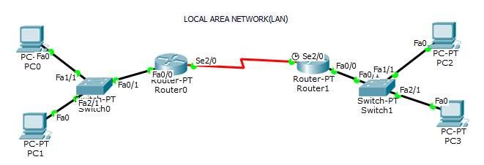

**Objective:**

This lab session will cover the following topics:

1. IP Addressing Basics
2. Connecting Computers in a Local Area Network (LAN) using Cisco Packet Tracer.
3. Network Configuration Commands
4. Study of Basic Network Commands

The primary goal is to understand how to configure network devices, assign IP addresses, and test network connectivity using basic commands in a simulated network environment.

**Part 1: IP Addressing Basics:**

**Understanding 32-bit IPv4 address:**

IP version 4 (IPv4) has 4 octets which means 32-bits.Just like a human’s identity is his name and passport number, in the same way, a computer’s identity over Internet is its IP address. Since computer understands binary values and humans understand decimal values, so an IPv4 address is normally written in decimal form. Let first understand an octet and then an IPv4 address.

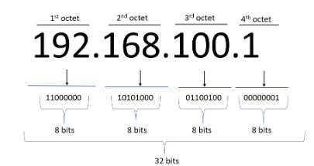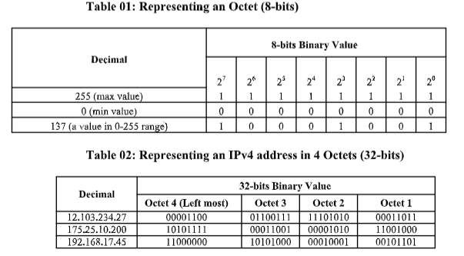

**Classification of IP address:**

Based on the value of left most octet, the IPv4 addresses have been divided into 5 groups. Each group fulfills specific need of required hosts and networks. A user can select the best suitable class for his/her home or organization network depending upon the number of hosts and networks.

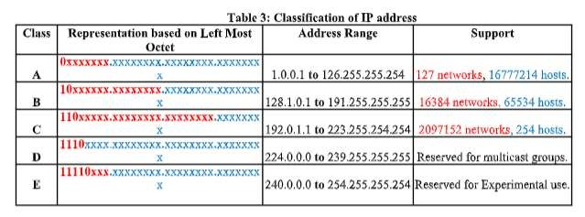

**IP Address Components:**

1. **IP Address**: A unique identifier for each device on the network (e.g., 192.168.1.10).
2. **Subnet Mask**: Divides the network into smaller sub-networks (e.g., 255.255.255.0).
3. **Default Gateway**: The router that connects the local network to other networks or the internet (e.g., 192.168.1.1).

**Classful IP Addressing**:

* **Class A**: 1.0.0.0 to 126.0.0.0 (Subnet: 255.0.0.0)
* **Class B**: 128.0.0.0 to 191.255.0.0 (Subnet: 255.255.0.0)
* **Class C**: 192.0.0.0 to 223.255.255.0 (Subnet: 255.255.255.0)

**Private IP Ranges (used for LAN)**:

* **Class A**: 10.0.0.0 – 10.255.255.255
* **Class B**: 172.16.0.0 – 172.31.255.255
* **Class C**: 192.168.0.0 – 192.168.255.255

##### Part 2: Connecting Computers in a Local Area Network (LAN)

**Step 1: Setting up Cisco Packet Tracer Workspace**

1. **Open Cisco Packet Tracer:**

**Start a new project with a blank workspace.**

1. **Add Devices to the Workspace:**

**Switch: Drag and drop a 2960 Switch from the Network Devices panel.**

**PCs: Drag and drop 4 PCs from the End Devices panel.**

1. **Connect Devices Using Copper Straight-Through Cables:**

**Use the Connections tool and select Copper Straight-Through and connect.**

##### Part 3: Network Configuration Commands

**Step 1: Assign IP Addresses Manually to Each PC**

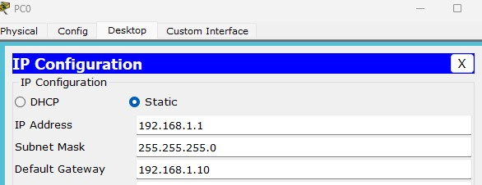

* Click on **PC’s**.
* Go to the **Desktop** tab and click **IP Configuration**.
* Set the following details: o **IP Address** o **Subnet Mask** o **Default Gateway** **Step 2: Router Configuration**

**Configuring Router 1:**

1. Select the router and Open CLI.
2. Press ENTER to start configuring Router1.
3. Type enable to activate the privileged mode.
4. Type config t (configure terminal) to access the configuration menu.

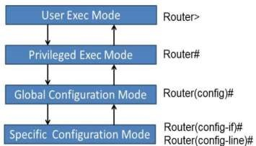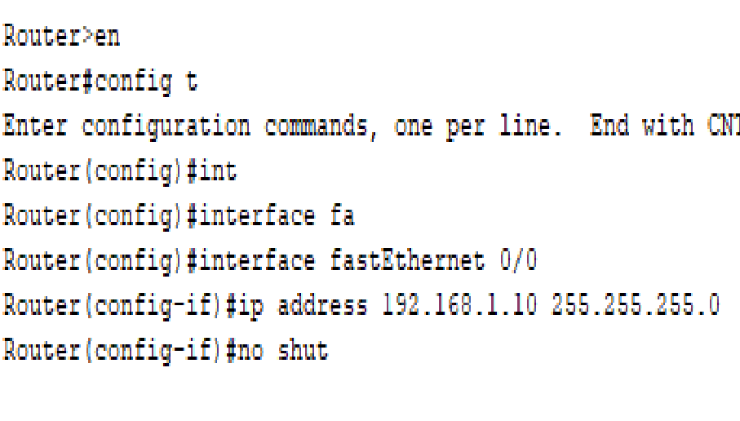

##### Part 4: Basic Network Commands

Once the LAN is set up and IP addresses are assigned, use the following basic network commands to verify the network's functionality and connectivity between devices.

**Ping Command**

The **Ping** command tests connectivity between two devices in the network.

• Open the **Command Prompt** under the **Desktop** tab.

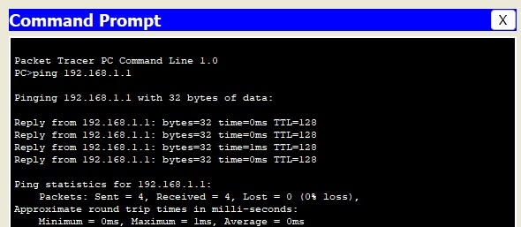

**Tracert Command**

The **Tracert** command shows the path taken by packets to reach a destination device or server.

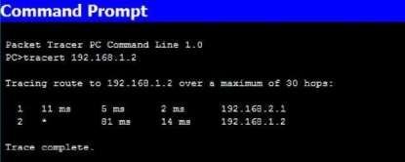

##### Task #1

Determine which class the following IP addresses belong to:

10.0.0.1

172.16.0.25

192.168.1.100

• **10.0.0.1** – **Class A**

• **172.16.0.25** – **Class B**

• **192.168.1.100** – **Class C**

##### Task #2

Explain which classes are commonly used for public and private networks

### ****Public Network Classes (used on the internet):****

* **Class A:** 1.0.0.0 to 9.255.255.255 (excluding private range)
* **Class B:** 128.0.0.0 to 172.15.255.255 and 172.32.0.0 to 191.255.255.255
* **Class C:** 192.0.0.0 to 192.167.255.255 and 192.169.0.0 to 223.255.255.255

##### Task #3

Create 2 local area network connected with each other and assign correct IP’s and check connectivity between networks.

Screen shots:

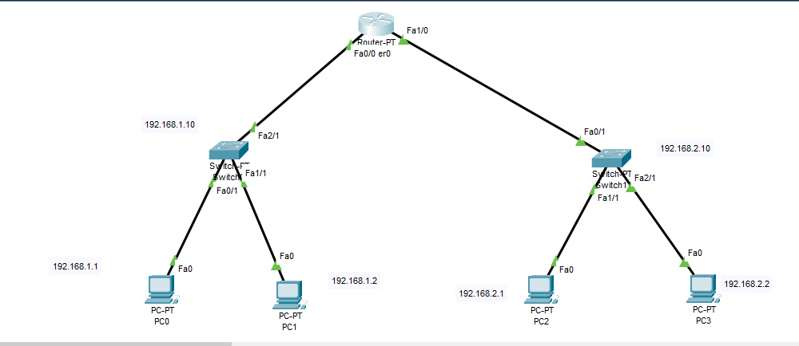

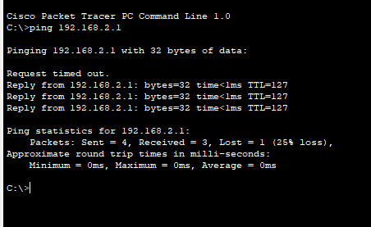

##### Lab Session 3

**Objective:**

To configure static routing on Cisco routers using Cisco Packet Tracer and verify network connectivity between different networks.

**Prerequisites:**

Basic understanding of networking concepts

Familiarity with Cisco Packet Tracer

Knowledge of basic commands **Static Routing:**

Uses a route that a network administrator enters into the router manually. Network administrators use static routing, or *non-adaptive routing*, to define a route when there is a single route or a preferred route for traffic to reach a destination. Static routing uses small routing tables with only one entry for each destination. It also requires less computation time than dynamic routing because each route is preconfigured.

**Lab Topology:**

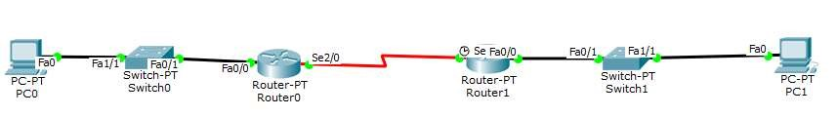

**Assign IP’s on Routers and PC’s:**

Router 0 (R0):

Interface Fa0/0: 192.168.1.1/24 (connected to PC1: 192.168.1.2/24)

Interface Se2/0: 10.0.0.1/8 (link to Router 2) Router 1 (R1):

Interface Fa0/0: 192.168.2.1/24 (connected to PC2: 192.168.2.2/24)

Interface Se2/0: 10.0.0.2/8 (link to Router 1)

**Configuration:**

Router> enable

Router configure terminal

Router(config) interface FastEthernet 0/0

Router(config-if) ip address 192.168.1.1 255.255.255.0

Router(config-if) no shutdown

Router(config-if) exit

Router(config) interface Se 0/1

Router(config-if) ip address 10.0.0.1 255.0.0.0

Router(config-if) no shutdown Router(config-if) exit

* Similarly configure router 1

**Configure Static Routes**

* Configure static routes on Router 1 (R1) to reach the 192.168.2.0/24 network

Router(config) ip route 192.168.2.0 255.255.255.0 10.0.0.2

* Configure static routes on Router 2 (R2) to reach the 192.168.1.0/24 network:

Router(config) ip route 192.168.1.0 255.255.255.0 10.0.0.1

* Configure IP Addresses on PCs and then verify the connectivity between LANs.

**Conclusion:**

In this lab, you successfully configured static routing between two routers. You learned how to set up static routes, assign IP addresses, and verify connectivity between different networks

##### Task 1

Create above topology and configure both routers.

Screenshots:

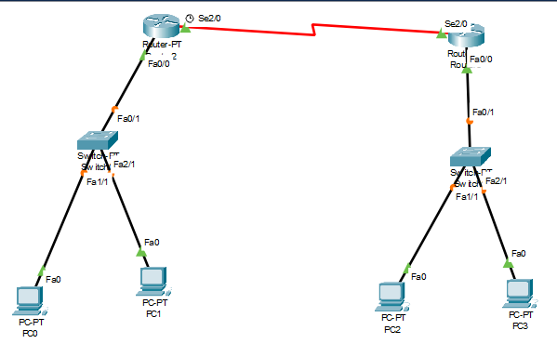

##### Task 2

A screenshot of successful pings from PC1 to PC2.

Screenshots:

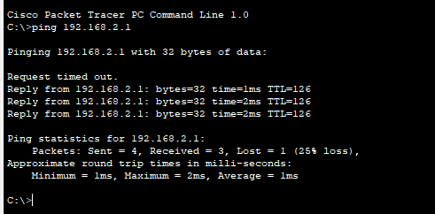

##### Task 3

Add a third router to the topology and configure static routing to extend the network.

Screenshots:

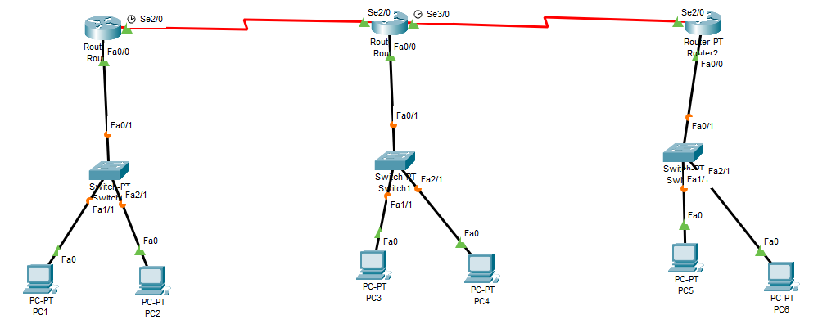

##### Lab Session 4

**Objective:**

To understand and implement Fixed-Length Subnet Mask (FLSM) Subnetting on Cisco routers, configure networks using equal-sized subnets, and verify connectivity between devices in different subnets using Cisco Packet Tracer.

**Introduction:**

Subnetting is the process of dividing a large network into smaller, more manageable sub-networks, known as subnets. This allows for more efficient use of IP addresses and enhances network performance and security. When Subnetting, we manipulate the subnet mask, which determines how many bits of an IP address are used for the network and how many are used for hosts.

There are two types of Subnetting techniques: FLSM (Fixed-Length Subnet Mask) and VLSM (Variable-Length Subnet Mask). In this lab session, we will focus on FLSM, where all subnets use the same subnet mask.

**Why We Need FLSM:**

FLSM simplifies network design, ensures consistent subnet sizes, enables efficient routing by using a uniform subnet mask, and facilitates easier IP address management for equal-sized networks.

In this lab, we will configure a network using FLSM on Cisco routers and verify communication between devices across different subnets.

**Example**:

Consider a class C network

IP Address: 192.168.1.0

Mask: 255.255.255.0

11111111 . 11111111 . 11111111 . 00000000

Take the first bit from the host portion (Fourth Octet) to create a subnet

Fourth Octet becomes 10000000

New subnet mask = 255.255.255.128

Number of subnets = 2n = 21 = 2

Block Size = 256 – 128= 128

Number of valid hosts per subnet = 27 – 2 = 126

Subnet1 Subnet2

192.168.1.0 Network address 192.168.1.128 Network address

192.168.1.1 --- 192.168.1.126 192.168.1.129 --- 192.168.1.254

192.168.1.127 Broadcast Address 192.168.1.255 Broadcast address

##### Task 1

Given the network **192.168.10.0/24**, divide it into **4 equal-sized subnets** using FLSM.

### ****Step-by-Step Solution:****

* **Original Network:** 192.168.10.0/24
* **Requirement:** 4 equal subnets
* **How many bits to borrow?**
  + 2 bits → 2^6 = 64 subnets
  + New subnet mask: **/26** (255.255.255.192)

##### Task 2

Calculate the subnet mask and the range of usable IP addresses for each subnet also mention Network Address and Broadcast Address.

| **Subnet** | **Network Address** | **First Host** | **Last Host** | **Broadcast Address** |
| --- | --- | --- | --- | --- |
| 1 | 192.168.10.0 | 192.168.10.1 | 192.168.10.62 | 192.168.10.63 |
| 2 | 192.168.10.64 | 192.168.10.65 | 192.168.10.126 | 192.168.10.127 |
| 3 | 192.168.10.128 | 192.168.10.129 | 192.168.10.190 | 192.168.10.191 |
| 4 | 192.168.10.192 | 192.168.10.193 | 192.168.10.254 | 192.168.10.255 |

##### Task 3

Implement FLSM on cisco packet tracer and ensure connectivity.

Screenshots:

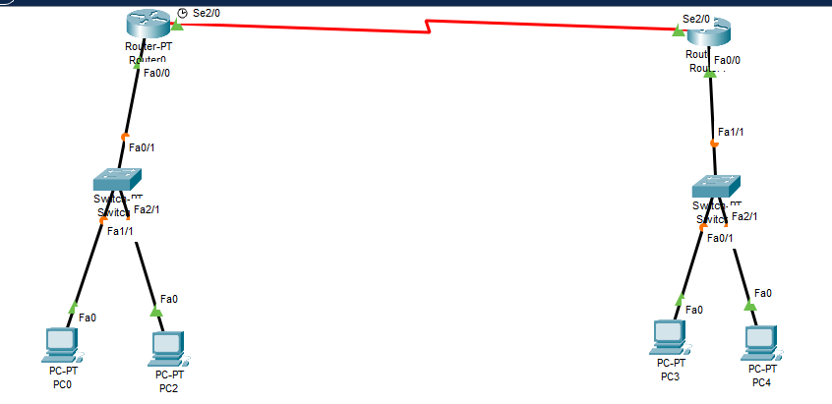

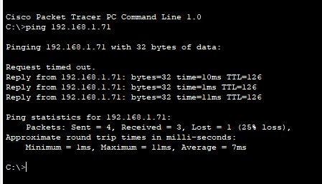

##### Lab Session 5

**Objective:**

To understand and implement Variable-Length Subnet Mask (VLSM) Subnetting on Cisco routers, configure networks using subnets of varying sizes based on network requirements, and verify connectivity between devices in different subnets using Cisco Packet Tracer.

**Introduction:**

In VLSM, subnets can have different sizes, allowing for the efficient allocation of IP addresses based on the number of hosts required in each subnet.

**Example:**

Consider the same Class C network:

IP Address: 192.168.1.0/24

Default Subnet Mask: 255.255.255.0

Binary Notation: 11111111.11111111.11111111.00000000

Using VLSM, we will create subnets of different sizes based on the number of hosts needed in each network. Assume the following requirements:

Subnet 1: 100 hosts

Subnet 2: 50 hosts

Subnet 3: 25 hosts

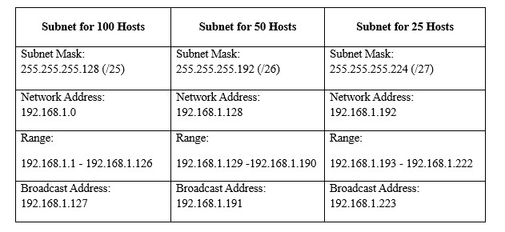

##### Task 1

Distribute a block of Class C IP address 192.168.1.0 as follows:

Subnet 1: 2 hosts

Subnet 2: 30 hosts

Subnet 3: 64 hosts

* At least **4 IPs** for 2 hosts (2 usable + network + broadcast) → **/30**
* At least **32 IPs** for 30 hosts → **/27**
* At least **66 IPs** for 64 hosts → **/26**

##### Task 2

Calculate the subnet mask and the range of usable IP addresses for each subnet also mention Network Address and Broadcast Address.

| **Subnet** | **CIDR** | **IP Range** | **Usable Hosts** | **Broadcast Address** |
| --- | --- | --- | --- | --- |
| Subnet 3 | /26 | 192.168.1.0 – 192.168.1.63 | 62 | 192.168.1.63 |
| Subnet 2 | /27 | 192.168.1.64 – 192.168.1.95 | 30 | 192.168.1.95 |
| Subnet 1 | /30 | 192.168.1.96 – 192.168.1.99 | 2 | 192.168.1.99 |

##### Task 3

Implement VLSM on cisco packet tracer and ensure connectivity.

Screenshots:

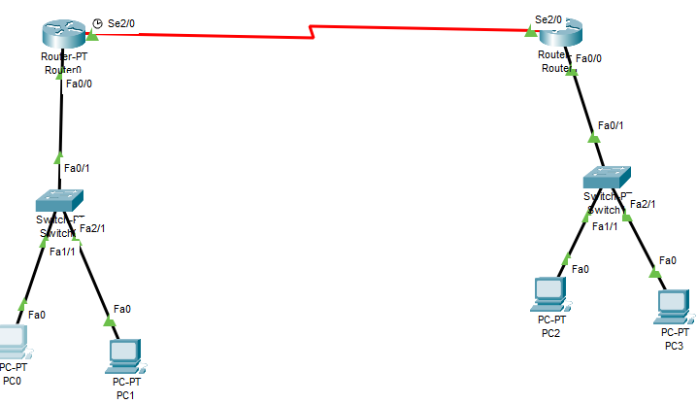

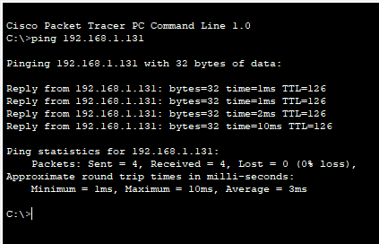

##### Lab Session 6 (Open-Ended Lab)

|  |  |  |  |  |
| --- | --- | --- | --- | --- |
| **Assignment of Open Ended Lab** / CCA / PBL | | | |  |
| **Blooms Taxonomy** | **GAs** | **Knowledge Profile** | **EAs** | WPs |
| P1  P2  P3  P4  P5 | GA-1  GA-2  GA-3  GA-4  GA-5  GA-6  GA-7  GA-18  GA-9  GA-10 | WK1  WK2  WK3  WK4  WK5  WK6  WK7  WK8 | EA1  EA2  EA3  EA4  EA5 | WP1  WP2  WP3  WP4  WP5  WP6  WP7 |

**Title: Dynamic Data Structures: Building a Real-Time Social Media Feed**

**Motivation:**

In the age of social media and instantaneous communication, the efficient management and presentation of dynamic data are of utmost importance. The primary objective of this laboratory is to offer students a practical opportunity to engage in the creation, execution, and enhancement of data structures capable of managing constant data flows, like those found in social media platforms. The laboratory fosters innovation, critical thinking, and the hands-on utilization of theoretical concepts in the realm of data structures.

**Concept (Problem Statement):**

Students will design and implement a data structure to simulate a real-time social media feed. The feed must handle operations like adding new posts, deleting old posts, updating posts, and efficiently retrieving the latest posts. The lab will also involve implementing features such as sorting posts by different criteria (e.g., timestamp, likes, relevance) and ensuring the system performs efficiently under various conditions.

**Design:** Students are required to follow the design constraints set out for the implementation of OEL:

* Introduction and Requirements
* Data Structure Selection
* Basic Implementation
* Performance Testing and Analysis
* Optimization and Advanced Features
* Extensions and Creativity

•

**Knowledge Profile Complex Activity Attributes**

•

|  |  |  |
| --- | --- | --- |
| **WK** • | **Short Name** | **Mapped with OEL** / CCA / PBL |
| WK1 • | Natural Sciences |  |
| WK2 • | Mathematics |  |
| WK3 • • | Engineering  Fundamentals |  |
| WK4 | Specialist Knowledge |  |
| WK5 | Engineering Design | ✓ |
| WK6 | Engineering Practice |  |
| WK7 | Comprehension |  |
| WK8 | Research Literature |  |

|  |  |  |
| --- | --- | --- |
| **WK** | **Short Name** | **Justification** |
| WP1 | Depth of knowledge required |  |
| WP2 | Range of conflicting requirements |  |
| WP3 | Depth of analysis required |  |
| WP4 | Familiarity of issues |  |
| WP5 | Extent of applicable codes | ✓ |
| WP6 | Extent of stake-holder involvement and conflicting requirements |  |
| WP7 | Interdependence |  |

•

**Complex Activity Attributes**

|  |  |
| --- | --- |
| **Attributes** | **Justification** |
| EA1: Range of resources |  |
| EA2: Level of interaction |  |
| EA3: Innovation |  |
| EA4: Consequences for society and the environment |  |
| EA5: Familiarity | ✓ |

##### Deliverables

**Background/Theory:**

**Procedure / Methodology:**

**Data Collection (If required):**

**Flowchart / Block diagram:**

**Analysis:**

**Results:**

**Discussion on Results: Concluding Remarks:**

**Reference:**

##### Lab Session 8

**Objective:**

To understand and implement dynamic routing using **RIP Version 1** on Cisco routers, configure networks to automatically exchange routing information, and verify connectivity between devices in different subnets using Cisco Packet Tracer.

**Introduction:**

Dynamic routing uses algorithms to compute multiple possible routes and determine the best path for traffic to travel through the network. It uses two types of complex algorithms: distance vector protocols and link state protocols.

In distance vector protocol, each router periodically shares it knowledge with its neighbours

◦ Shares knowledge about entire AS

◦ Shares only with neighbours

◦ Shares at regular intervals

Examples of Distance Vector routing protocols:

◦ Routing Information Protocol (RIP)

◦ Interior Gateway Routing Protocol (IGRP)

◦ Enhanced Interior Gateway Routing Protocol (EIGRP) **Routing Information Protocol (RIP):**

RIP, or **Routing Information Protocol**, is one of the oldest and most widely used dynamic routing protocols in computer networks. It is a distance-vector protocol that enables routers to exchange routing information and determine the best paths for forwarding packets across an internetwork. RIP operates using a simple metric: hop count, which refers to the number of routers (hops) a packet must traverse to reach its destination.

There are two versions of RIP: RIP Version 1 (RIPv1) and RIP Version 2 (RIPv2).

|  |  |
| --- | --- |
| **RIPv1** | **RIPv2** |
| A classful distance vector routing protocol | A classless distance vector routing protocol that is an enhancement of RIPv1’s features |
| Does not support dis-contiguous subnets | Support dis-contiguous networks |
| Does not support VLSM | Support VLSM |

**RIP v1 Configuration:**

* First, click on router0 then Go to CLI.
* Then type the commands and IP information given below.

CLI command : router rip

CLI command : network <network id>

**Lab Topology:**

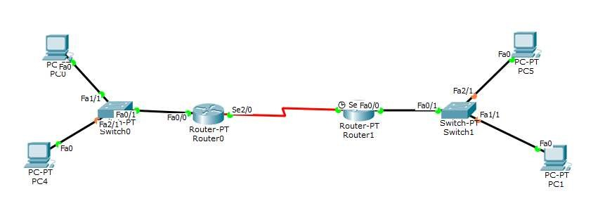

RIP Routes for Router0 are given below:

Router(config)#router rip

Router(config-router)#network 192.168.10.0

Router(config-router)#network 10.0.0.0

RIP Routes for Router1 are given below:

Router(config)#router rip

Router(config-router)#network 192.168.20.0

Router(config-router)#network 10.0.0.0

Router(config-router)#network 11.0.0.0

##### Task 1

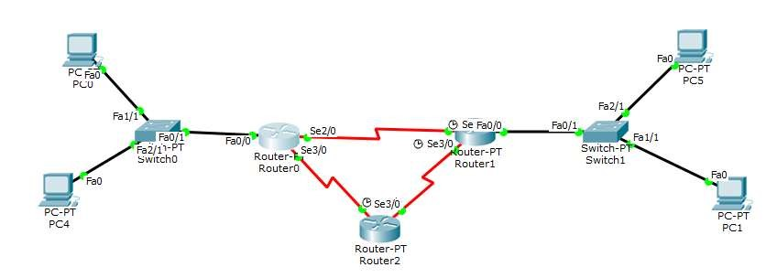

Assign IP Addresses to the above topology.

Screenshots: 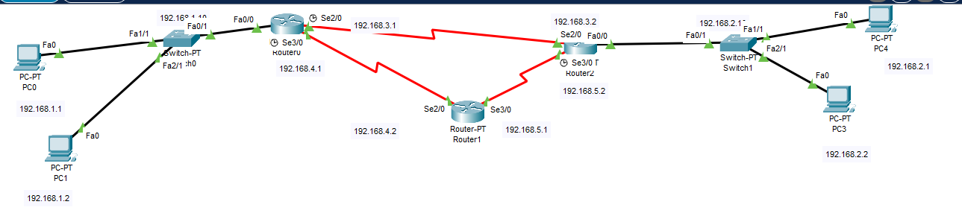

##### Task 2

Configure RIP v1 on all routers.

Screenshots:

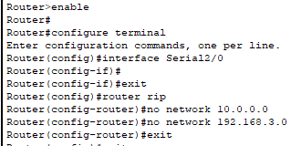

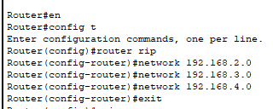

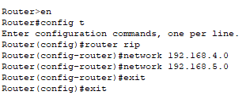

##### Task 3

Use Ping Command to ensure connectivity.

Screenshots:

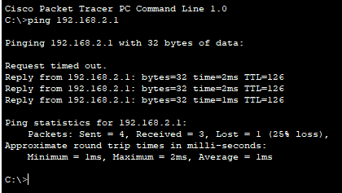

##### Lab Session 9

**Objective:**

To understand and implement dynamic routing using **RIP Version 2** on Cisco routers, configure networks to automatically exchange routing information, and verify connectivity between devices in different subnets using Cisco Packet Tracer.

**Introduction:**

RIP Version 2 (RIPv2) is an enhanced version of the Routing Information Protocol (RIP), designed to address some of the limitations of its predecessor, RIP Version 1 (RIPv1). RIPv2 is a dynamic distance-vector routing protocol that allows routers to exchange routing information and make intelligent routing decisions based on hop count and additional features.

**Key features of RIPv2 include:**

1. **Classless Routing**: Unlike RIPv1, which is a classful routing protocol, RIPv2 supports classless routing. This allows for the use of variable-length subnet masks (VLSM), enabling more efficient IP address utilization and better support for complex network designs.
2. **Multicast Updates**: RIPv2 uses multicast addresses (specifically 224.0.0.9) to send routing updates, as opposed to broadcasting them to all devices on the network. This reduces unnecessary network traffic and enhances efficiency.
3. **Route Authentication**: RIPv2 includes support for authentication, allowing network administrators to secure routing updates and prevent unauthorized access. This is crucial for maintaining the integrity of the routing table.
4. **Route Tagging**: RIPv2 supports route tagging, which allows additional information to be included with routing updates. This can help in route filtering and route manipulation for more advanced routing policies.
5. **Enhanced Network Scalability**: By supporting classless routing and providing more efficient updates, RIPv2 allows networks to scale better than RIPv1, making it suitable for larger and more complex networks.

In this lab session, we will configure RIPv2 on Cisco routers, enabling dynamic routing within a network. We will also explore how RIPv2 improves routing efficiency and adaptability compared to its predecessor. Through this practical experience, students will understand the implementation and advantages of RIPv2 in modern networking environments.

**RIP v2 Configuration:**

* First, click on router0 then Go to CLI.
* Then type the commands and IP information given below.

CLI command: router rip

CLI command: version 2

CLI command: network <network id>

**Lab Topology:**



RIP Routes for Router0 are given below:

Router(config)#router rip

Router(config)#version 2

Router(config-router)#network 192.168.10.0

Router(config-router)#network 10.0.0.0

RIP Routes for Router1 are given below:

Router(config)#router rip

Router(config)#version 2

Router(config-router)#network 192.168.20.0

Router(config-router)#network 10.0.0.0

Router(config-router)#network 11.0.0.0

##### Task 1



Assign IP Addresses to the above topology.

Screenshots:

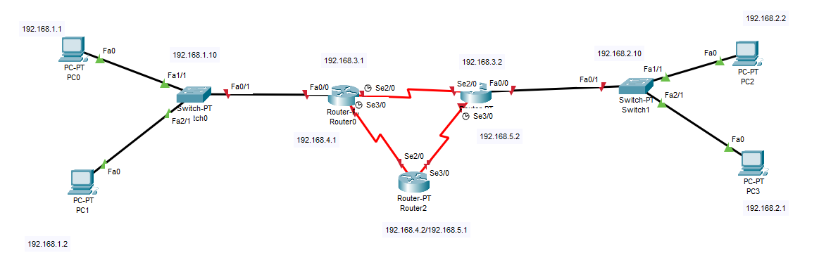

##### Task 2

Configure RIP v2 on all routers.

Screenshots:

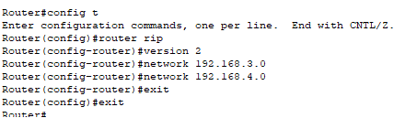

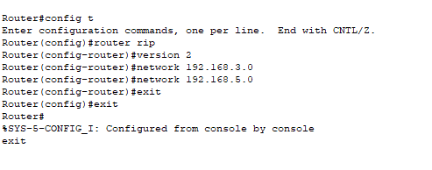

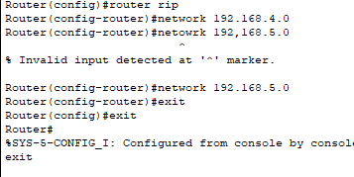

##### Task 3

Use Ping Command to ensure connectivity.

Screenshots:

